This is my friend. His name is Menua. 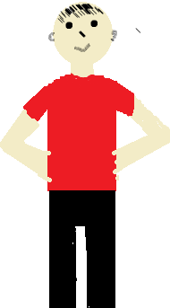
He is seven.
He has short black hair and black eyes.
He is wearing a red shirt and black jeans.
He is a kind boy and a good friend.

